**Tester as DUT test execution setup using automation tool.**

**Case 1: TPR as DUT.**

1. **Make sure both Testers are available for access in LAN.**
   1. Open the tool and click  (Run) -> MPP_TPT -> Connect tester.

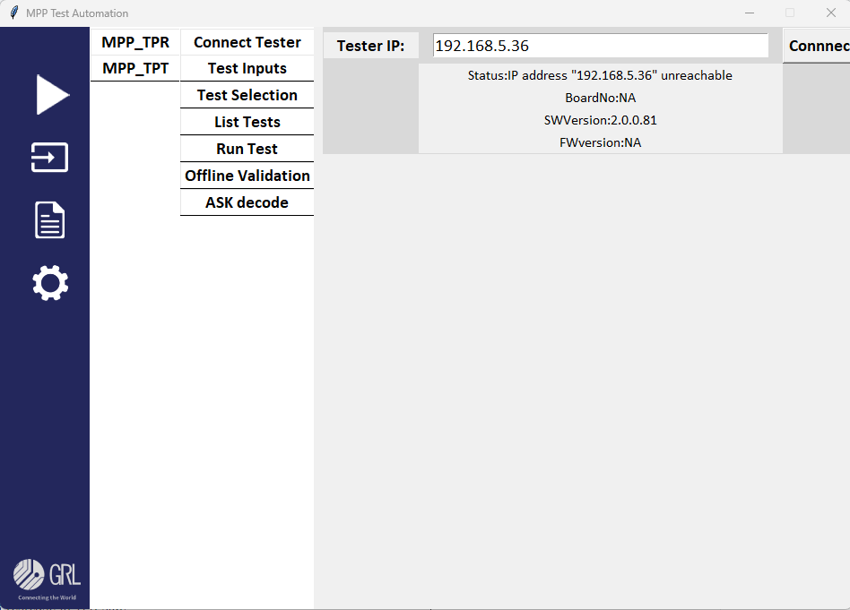

* 1. Provide valid tester IP address in Tester IP box and click ***connect***. If the IP is valid the status will be updated as connected and shown tester details below the box.

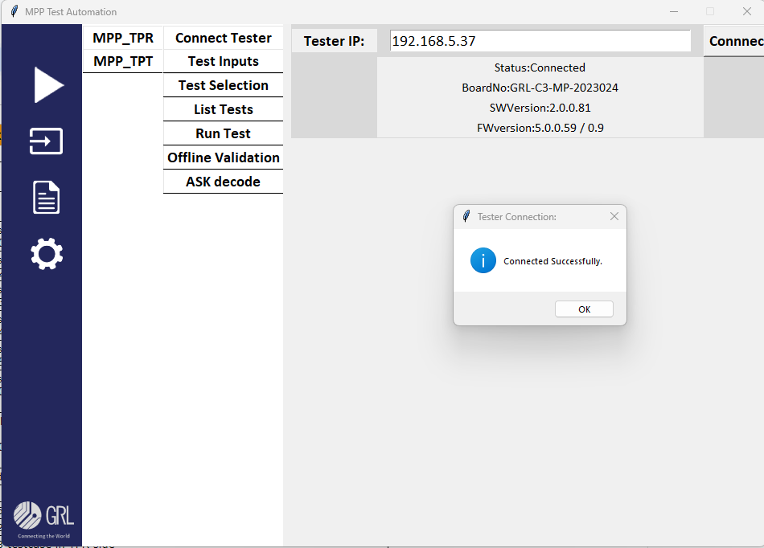

* 1. Same way connects the TPR by click  (Run) -> MPP_TPR-> Connect tester.

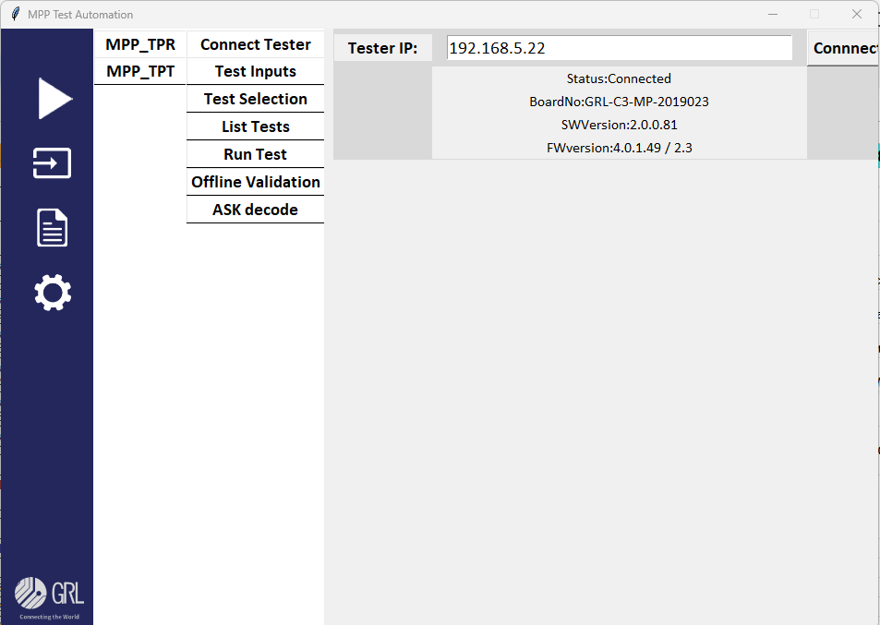

1. **Provide Test inputs (Qi configuration setup) for both Testers.**
   1. For TPT, click  (Run) -> MPP_TPR-> Test Inputs. Provide Inputs and click update button.

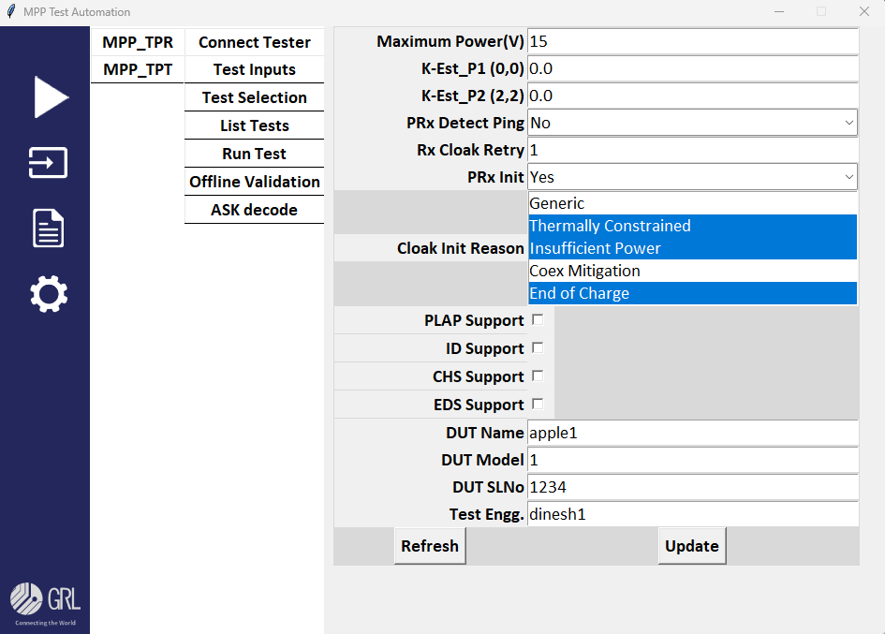

* 1. Same way provides test inputs for TPR by clicking click  (Run) -> MPP_TPT-> Test Inputs 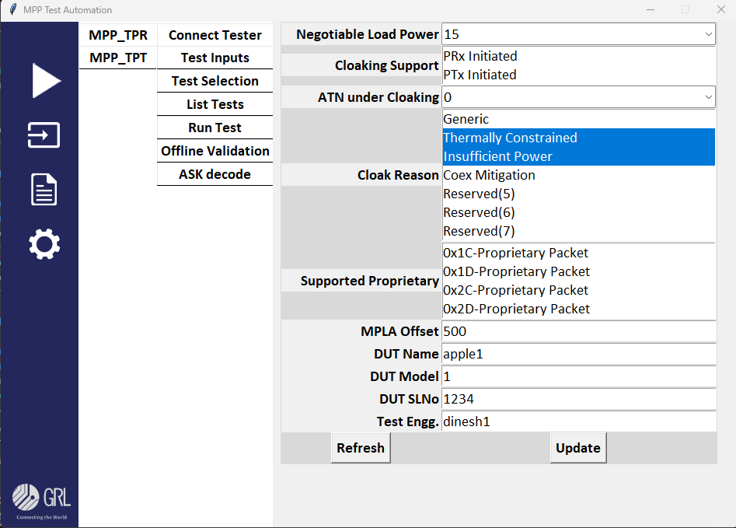

1. **Select tests from TPT end to run.**
   1. click  (Run) -> MPP_TPT-> Test Selection. From the below window select phase and position combination and click Generate Tests button to make the list of tests to be run.

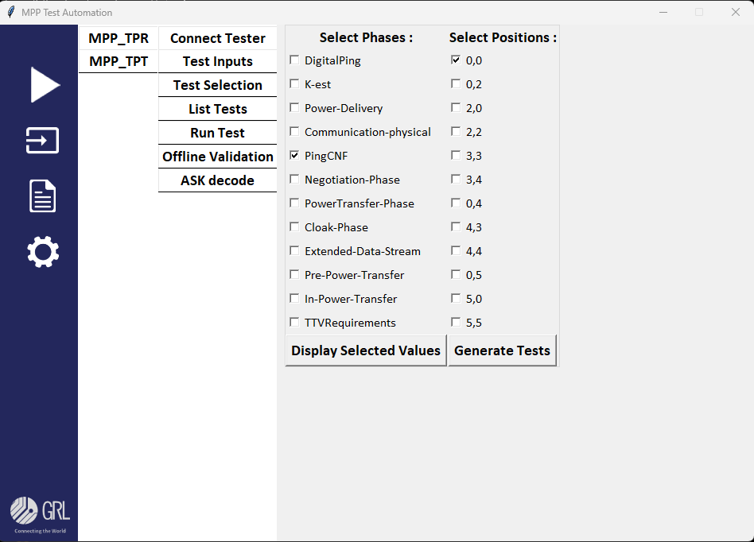

* 1. to view the prepared tests list, click  (Run) -> MPP_TPT-> List Test. From the below window select position to view the available tests under the positions.

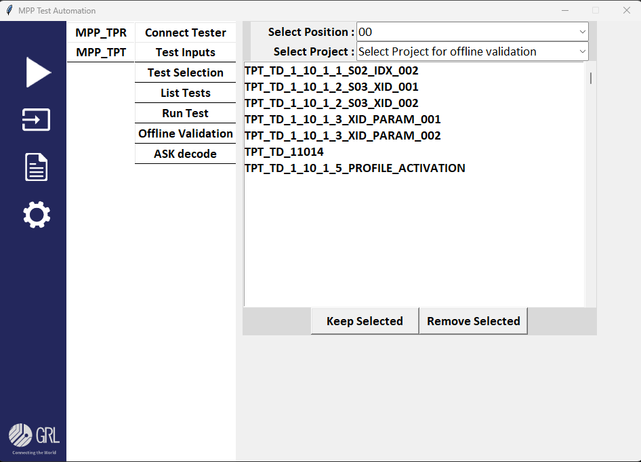

If required can select the tests from the list and remove by using the buttons Keep selected and Remove Selected.

Note: The mapping for the tests which has to be run from the TPR side will already be mapped by the developer, so user no need to give any input for the same.

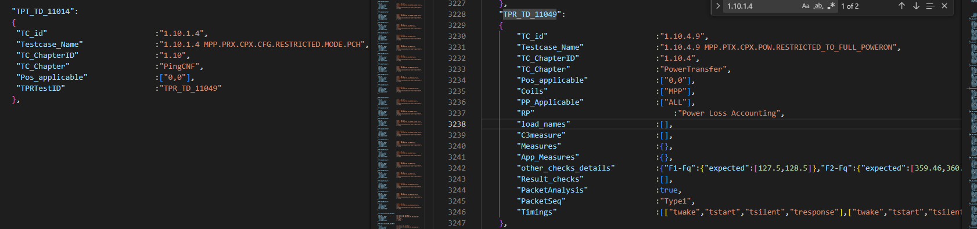

1. **Run Test**
   1. click  (Run) -> MPP_TPT-> Run Test.

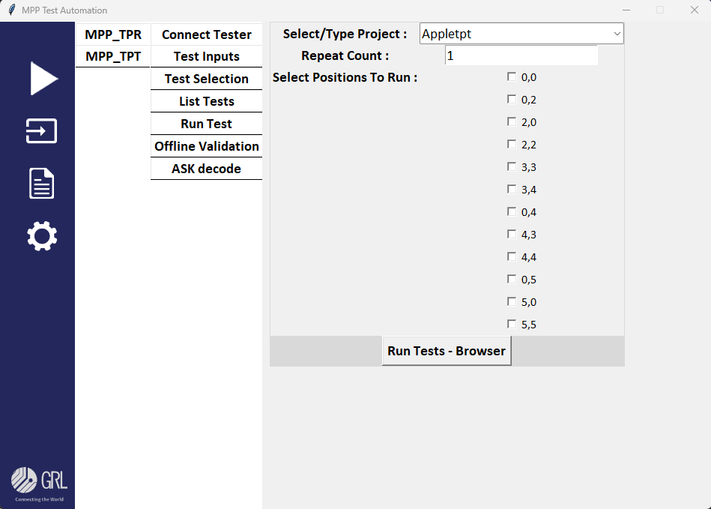

* 1. Provide Project Type, repeat count and select positions and click **Run Tests-API** button to start the testing. Multiple position also can be selected for single run. For each position the prepare list of tests in the step iii will be executed one by one by triggering its mapped tests in the TPR with delay of 5sec.
  2. Since in-depth validation applied for TPR tests the all CTS checks will be validated and create the report, for TPT the validation task is still InProgress state as of now the detailed CTS checks will not be handled, only the execution of the test will take place.